Economics 358 Assignment 1 (version B)

This assignment has a maximum total of 100 marks and is worth 20 percent of your total grade for this course. You should complete it after completing your course work for Units.
2 through 5. Answer each question clearly and concisely.

- Explain the meaning of LM curve. Why does it have a positive slope? What factors determine the flatness or steepness of the LM curve? (10 marks)
LM curve represents the interest rate in liquidity form and the set of all levels of income.
Lm has a positive slope because the higher the income will lead to an increased demand for money.

factors determine the flatness or steepness of the LM curve
The elasticity of demand for money to the changes in the rate of interest: when the elasticity of liquidity is low concerning changes in the interest rate, the LM curve will be very steep. The higher the elasticity of liquidity preferences to the interest rate changes, the LM curve will be less steep.
The demand for money changes in income: when the income increase, the demand curve of money will also increase. The extra demand for money will cause the interest rate to increase, which shifts the equilibrium to a new position. Therefore, money under transaction motive will higher while the money held at the speculative motive will decline. The higher the rate of interest, the steeper the LM curve.

- Use the IS-LM graph to determine the effects on the equilibrium level of income (output) and the interest rate of an increase in the money supply. Why do income and the interest rate move in the opposite direction? (15 marks)

When there is a higher level of income, the demand curve shifts to the right, leading to an increase in the interest rate that the money supply equals money demand. When the interest rate decreases, it increases the need for more money because it is relatively low until money demand equals money supply. Income and interest rate moves in the opposite direction to make sure money demand equals money supplied.
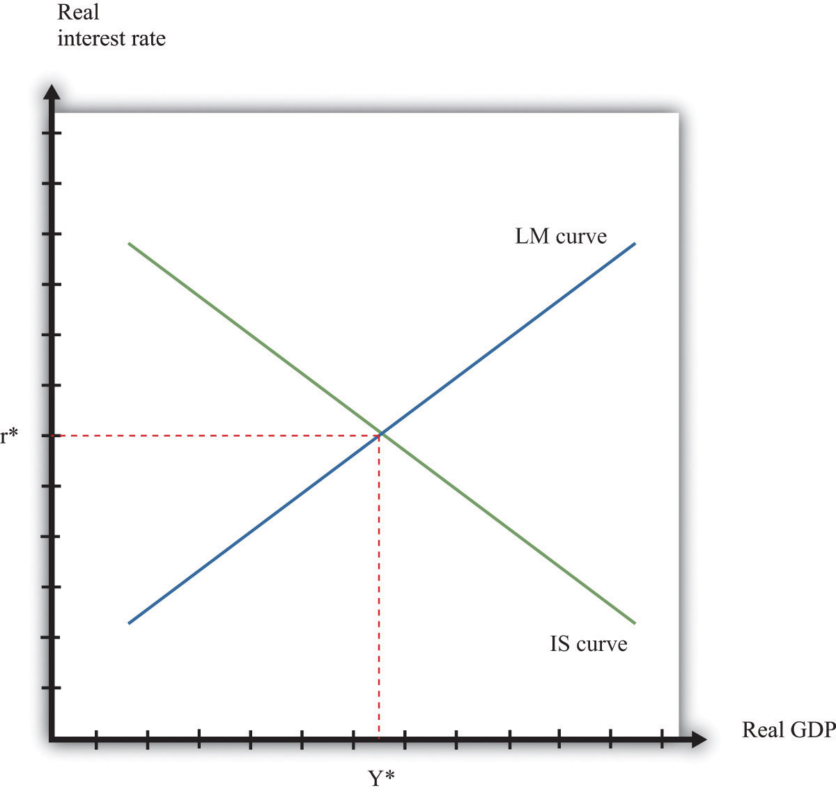

- How is the LM curve altered by introducing international trade? How is it changed under fixed exchange rates? How is it changed under flexible exchange rates? What is the effect on the LM curve of an increase in foreign exchange reserves? (15 marks)

The LM curve refers to the combination of interest rate and income where the demand for money is equal to the market's money supply.
How is altered by introducing international trade.
The introduction of international trade increases interest rates, reducing the demand for money while the income increases. To keep the demand for money in equilibrium, the income level increases where the demand for money equals the supply of money, thus leading to the LM curve.
How is it altered under fixed exchange rates?
Under a fixed exchange rate, the lower the price, the higher the purchases of goods. This means there will be a devaluation of the currency. Therefore, more currency is needed to buy the same amount of goods in a foreign country.
When export increases, it results in the revaluation of currency where the local consumer will require less currency to purchase the same commodity unit in a foreign country.

The effect on the LM curve of an increase in foreign exchange reserves results in to increase in demand for home bonds. The LM curve increases and shifts upward to a new equilibrium because of the rise in demand for money.
- Define the Marshall-Lerner condition. What are the likely effects of devaluation on a small country that purchases imports in a large world market and sells its exports in such a market? (10 marks)

The Marshall- learner condition explains that devaluation in the exchange rate currencies will result in a better balance of trade as long as import and expert have elasticity more than unity and if the home currency devalues in import costlier with cheap export of relative prices of two currencies.
Devaluation of currency is only suitable for export only. When the export is cheap people will spend more money on importing goods. This will lead to a decline in the living standard of people because of much spending. Reduction in domestic currency makes export cheap and import costly this will benefit the small country because it will lead to more exports.

- Explain the J-curve phenomenon. Consider an economy with a fixed exchange rate with a fixed price level. What is the effect of depreciation on equilibrium income and trade balance after the first six months of depreciation? (10 marks)

J – curve is a situation where a negative return is followed by a gradual recovery that increases the economy's stability before it declines. J –curve effect is seen when a country's balance of trade initially worsens because of its currency devaluation, and then it quickly recovers and becomes stable.
Depreciation of equilibrium income affects the purchasing power of money balance. This lead to the consumption of domestic products and a reduction in imports. Depreciation in equilibrium income leads to a lower exchange rate, which leads to less import and more export, thus leads to a more significant surplus in the country. Local consumers purchase more local goods than import goods, thus improving the balance of trade, and eventually, it recovers to a better level, thus increasing the balance of trade.

- Define uncovered interest parity. What is the relationship between the forward exchange rate, the spot exchange rate, and the interest rate? Suppose the (1-year) interest rate on bank deposits is 2% in Canada and 1.5% in the United States. If the
(1-year) forward US$–C$ exchange rate is C$1.5 per US$ and the spot rate is C$1.2 per US$, what is the expected US$–C$ exchange rate one year ahead? (15 marks)

Uncovered interest parity is the position where the nominal interest rate between two nations is equal to changes in the foreign exchange rate over the same time.

Spot exchange rate refers to the amount one currency will be exchanged with another currency then. In forwarding exchange rate is the future exchange rate. Two countries can negotiate about the future exchange rate of their currencies.
The main relationship between the two exchange rate is
F(Forward exchange rate)=S(Spot exchange rate)×(1+interest rate in the domestic country)/(!1+rate in foreign currency country)
This means that the current one is assumed to be domestic, while currency 2 is the domestic currency.

Foreign exchange rate=1.5× (1.02/1.015) =1.5×1.005==1.0251=1.5075

.
- Define the real exchange rate. Suppose that the cost of the market basket in Canada is P_{CA} = $190. Fill in the blank cells of the table below. (Hint: Use a spreadsheet application such as Excel.) (10 marks)

Country  (currency measured in FX units) | Per $,  E_{FX/$} | Price of the market basket (in FX) | Price of Canadian basket in FX (P_{CA} times E_{FX/$}) | Real exchange rate, ϵ
Brazil (real) | 2.1893 | 520 | 415.967 | 0.80
Cyprus (Cy£) | 0.45 | 75 | 85.5 | 1.14
India (rupee) | 46.6672 | 12,000 | 8866.768 | 0.7389
Mexico (peso) | 11.0131 | 1,800 | 2092.489 | 0.1162
S. Africa (rand) | 6.9294 | 800 | 1,316.586 | 1.6457
Zimbabwe (ZW$) | 101,347 | 4,000,000 | 19255930 | 4.814

- Consider the following economy. Suppose the real exchange rate is fixed and equal to one. The consumption (C), investment (I), government spending (G), taxes (T), exports (X), and imports (Q) are given by:

Z = C + I + G + (X – Q)
C = 120 + 0.80(Y – T)
I = 210
G = 500
X = 300
T = 50 + 0.25Y
Q = 30 + 0.1Y

Where Y is the domestic income.

- Based on the above information, derive the planned aggregate expenditure as
A function of Y (Hint: derive the ZZ curve – aka the AE curve). Sketch the Keynesian cross diagram of the above economy and indicate the equilibrium
level of income (output). (5 marks)

- Calculate the equilibrium level of income. (5 marks)

- Calculate the amount of taxes collected when the economy is at the equilibrium level of output. Is the government running a surplus or deficit, and by how much?

(2.5 marks)

- Calculate the value of net exports when the economy is at the equilibrium level of output. (2.5 marks)
